First produce the database from the spreadsheet

Create a database out of a spreadsheet choose <File><Wizards><Address Data Source> and select external data source, click next, select database type = spreadsheet and browse for the spreadsheet you want to use.
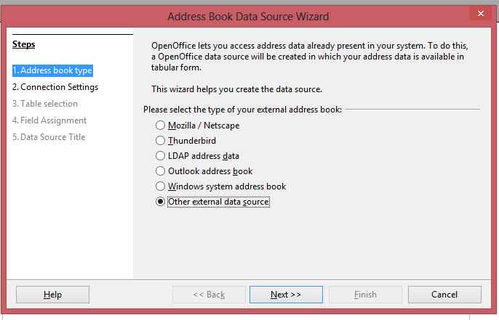
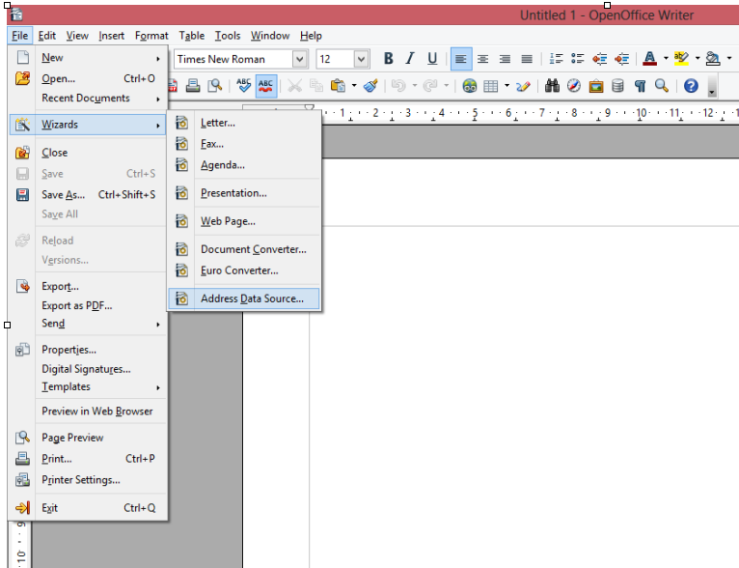
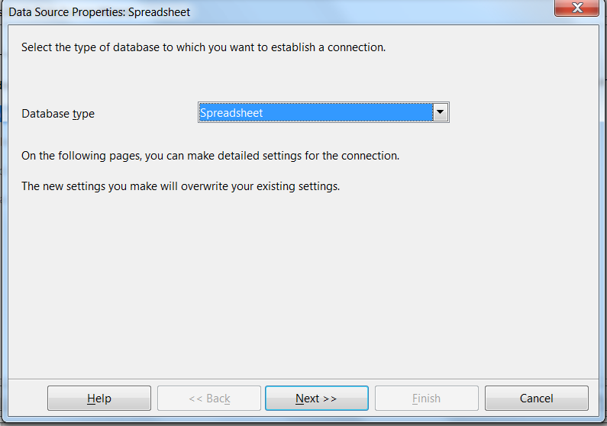
..

Click Field Assigment

Assign the variables in your spreadsheet to those in Open Office and then click OK and then click Finish to produce the database

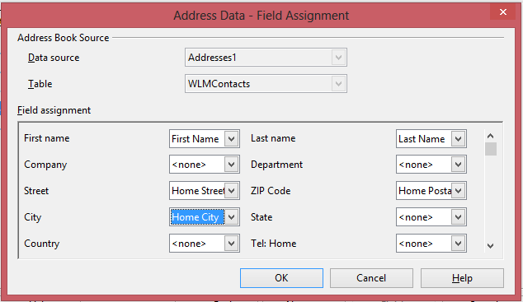

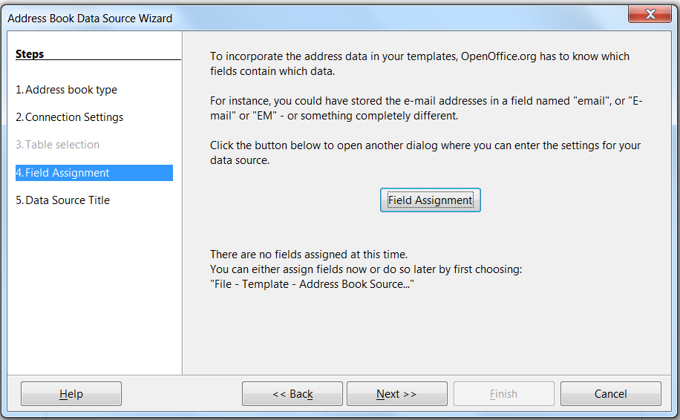

Menu <File><New><Labels>

Labels dialog appears, use it to set out the format and content of labels. Click the tab “Options” and select synchronise contents, this helps when making changes to formats.

Press new document

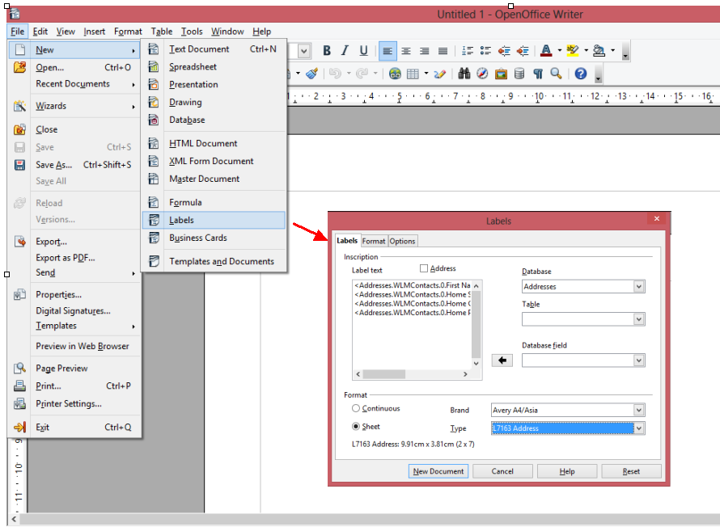
And you get the document with the fields ready
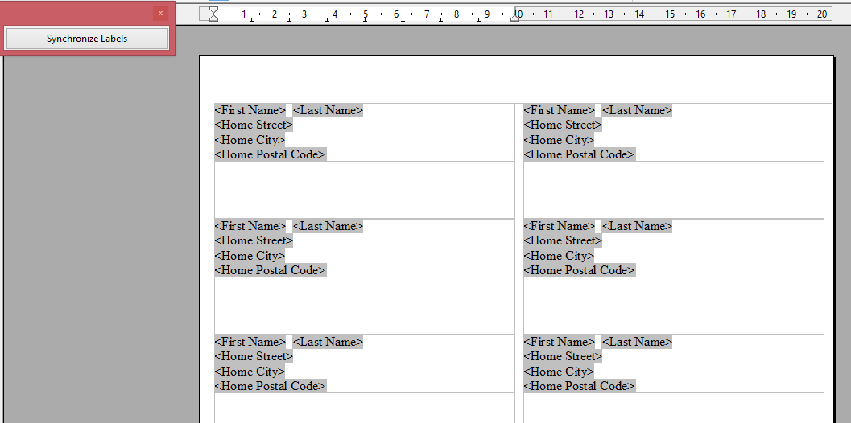
Select Print from the File menu and you get this question, click “Yes”
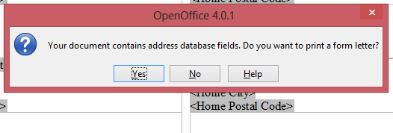
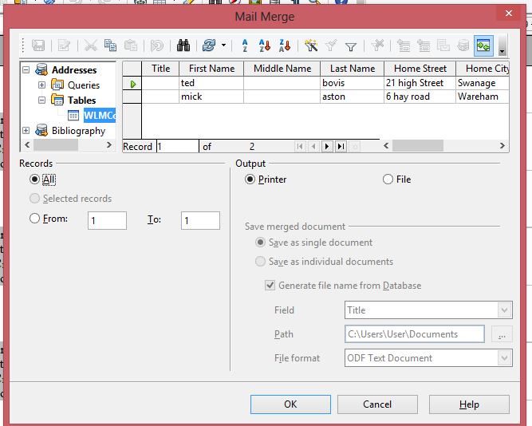
Select the database you want, and then choose whether you want all the records or just some of them. NB you are advised to click radio button ‘output to file’ then you can check and adjust labels on screen before printing.

